**TCP Web Server Assignment**

**Marvin Newlin**

**14 Nov 18**

**CSCE 560**

1. Hardcopy of complete server code

See Attached

1. Screenshot of your client browser when you successfully retrieve a file from the server



1. Screenshot of Wireshark (filter out all packets except those pertaining to the HTTP transaction) when you successfully retrieve a file from the server



These are the three packets that contain the HTTP request/response/data. Their contents are displayed below

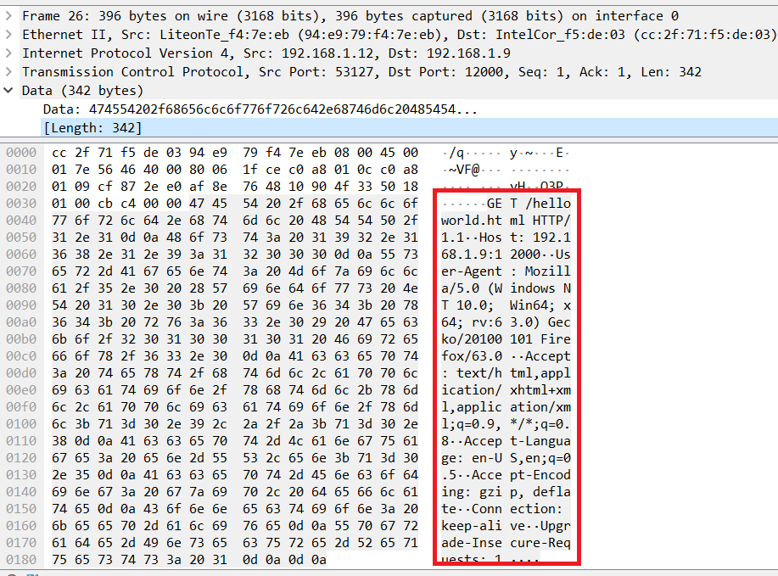

This is the packet capture that contains the HTTP request data (red box above)

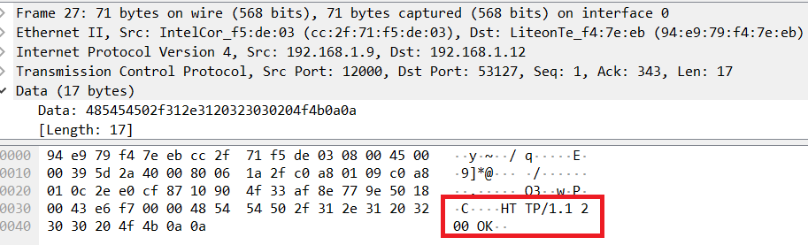

This is the packet capture that contains the HTTP response (red box above)

1. Screenshot of your client browser when the requested file is not found on the server

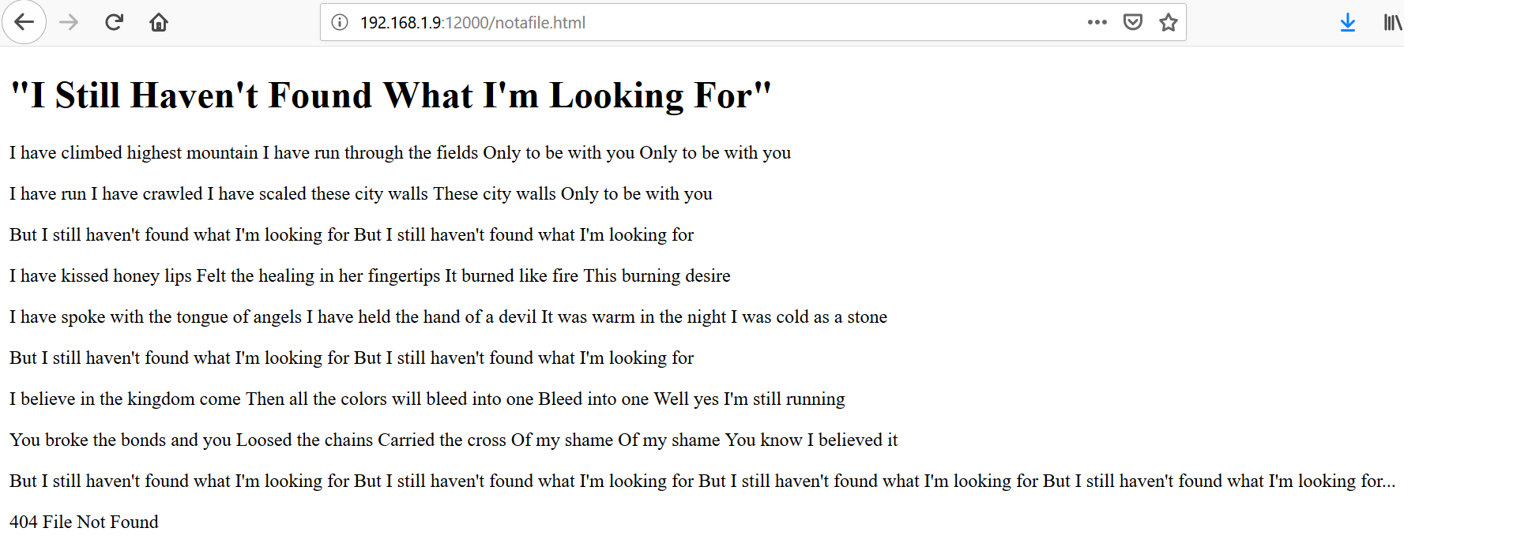

1. Screenshot of Wireshark (filter out all packets except those pertaining to the HTTP transaction) when the requested file is not found on the server



These are the packets involved in the request for the nonexistent file. Their contents are below.

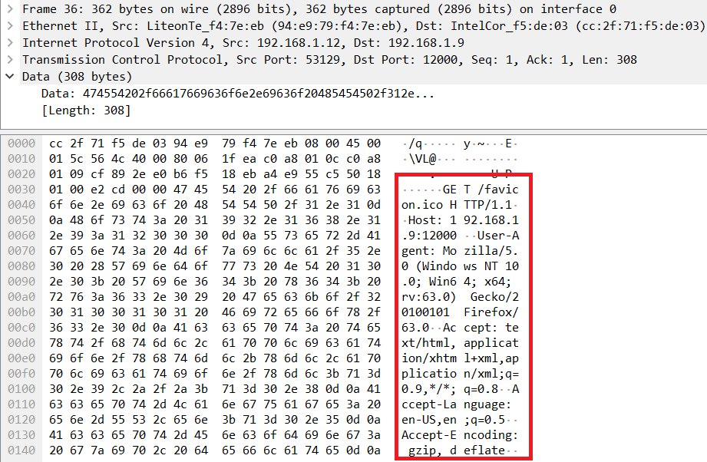

This is the request for the nonexistent file (red box above)

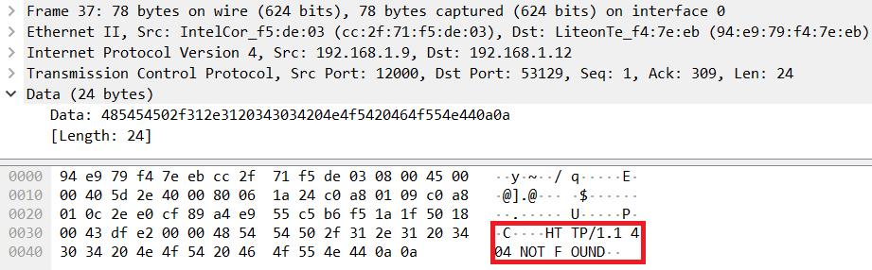

(response of HTTP 404 NOT FOUND) (red box above)

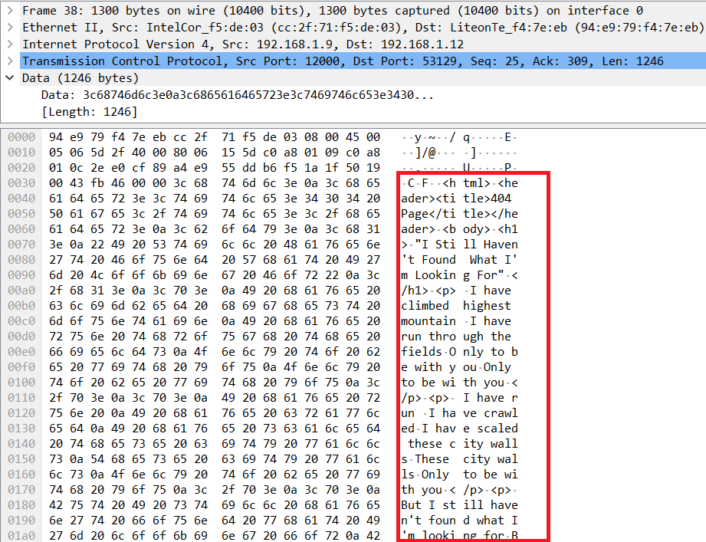

Response with contents of HTML file for a 404 error (red box above) (not all contents shown due to length of file).

1. Source code of any transferred files (e.g., helloworld.html, customerror.html)

See attached